**Cricket League Management**

**Submitted by:**

|  |  |
| --- | --- |
| **Name** | **Reg. no** |
| Ahmad Hassan | SP24-BSE-008 |
| Muhammad Ammar Qasim | SP24-BSE-029 |
| Muhammad Abdullah Qaisrani | SP24-BSE-151 |

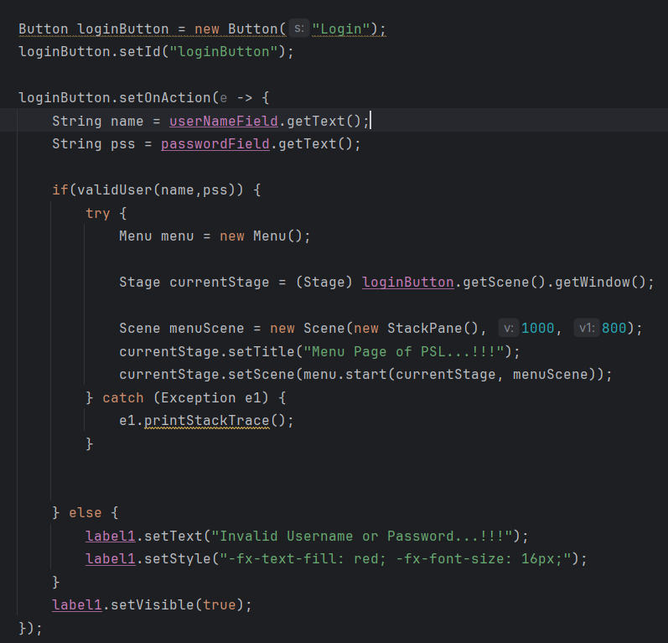**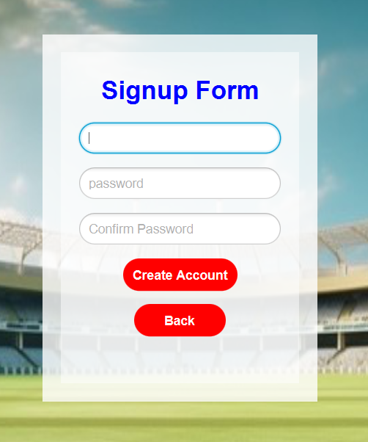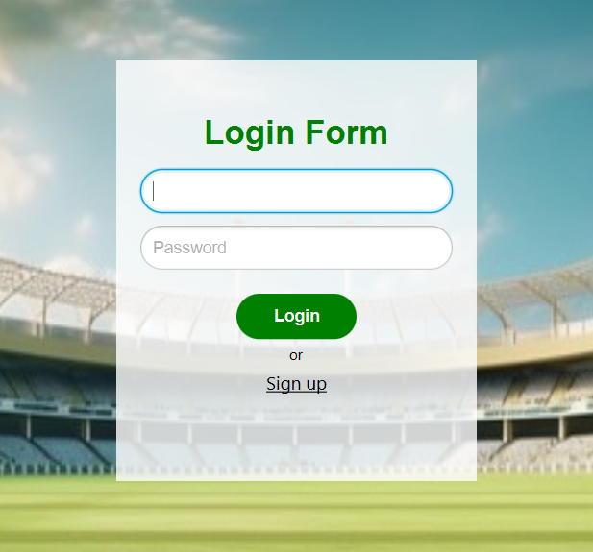Cricket League Management**

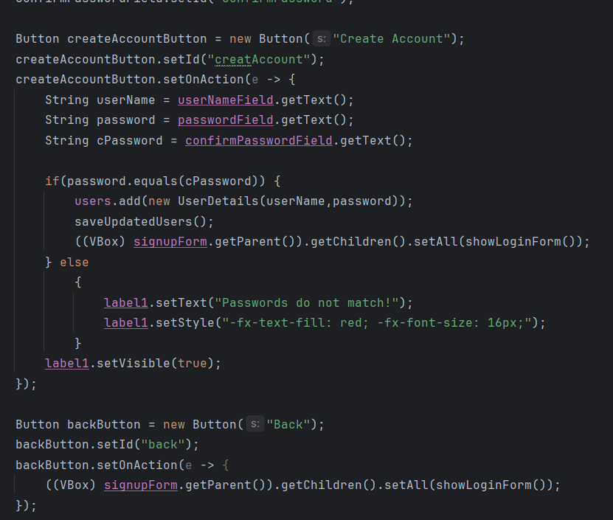

These are the Login page and signup page of our project.   
**Login Form:**

the data of user is already stored in a file. When I click on login button, it matches the given data from file, if the data matches, it takes us to new menu scene otherwise it prints a message below that the information is invalid.

**Sign Up Form:**

In this form, the new user enter his or her details and when he clicks on the creat account button, it saves the user data in a file.

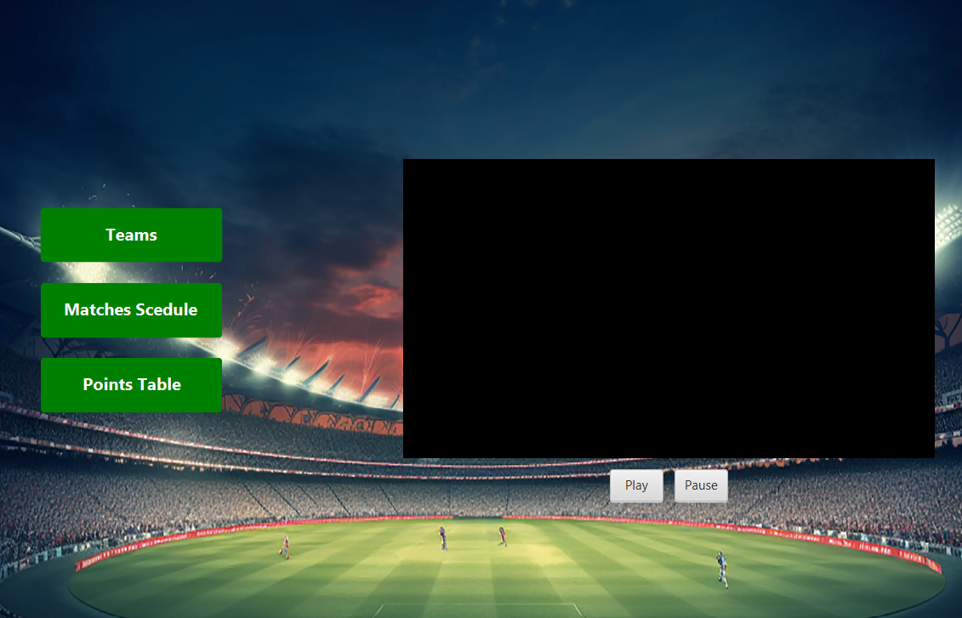

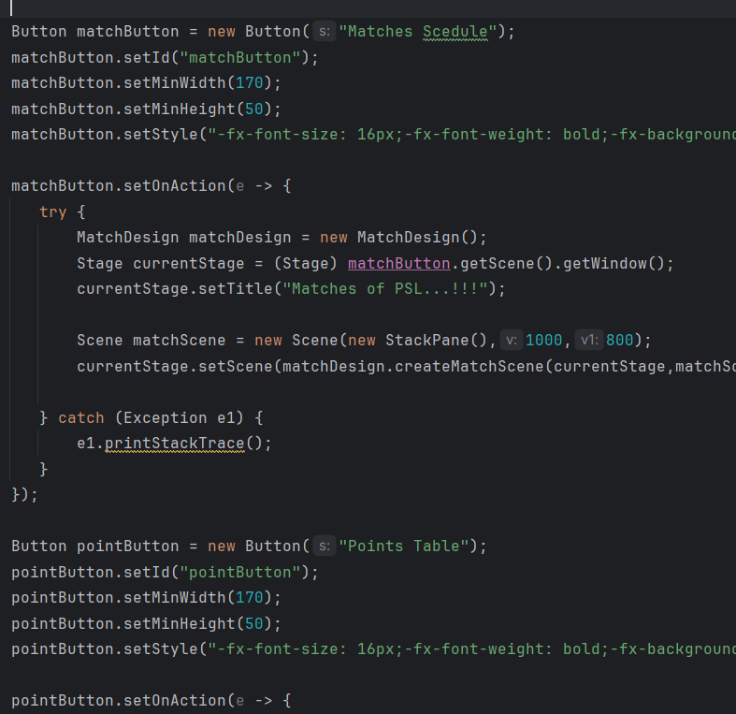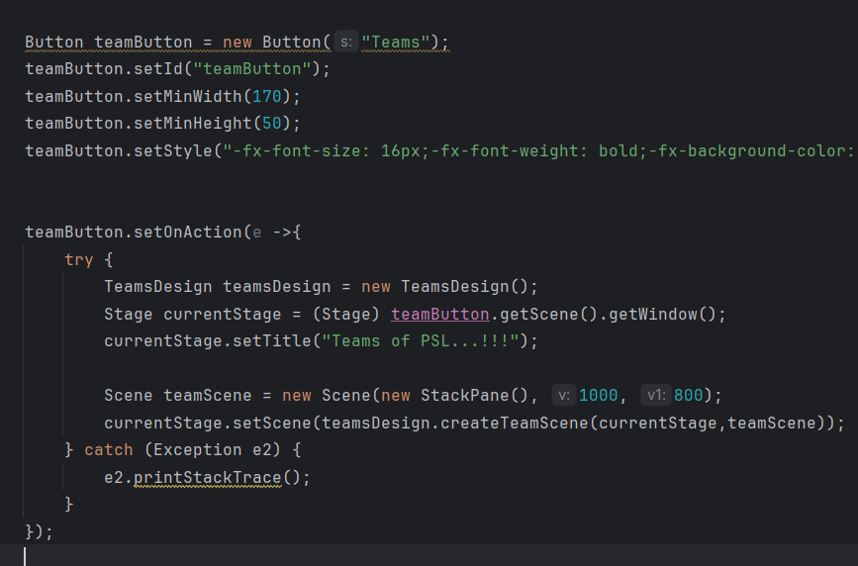

**Menu Page:**

This is the menu page of my project. In this page there is a cricket league song. In this when the user clicks on teams button, it shows the teams which are added in the league. The when he clicks the matches schedule, it shows the details of matches and the points table button shows the points table of the league.

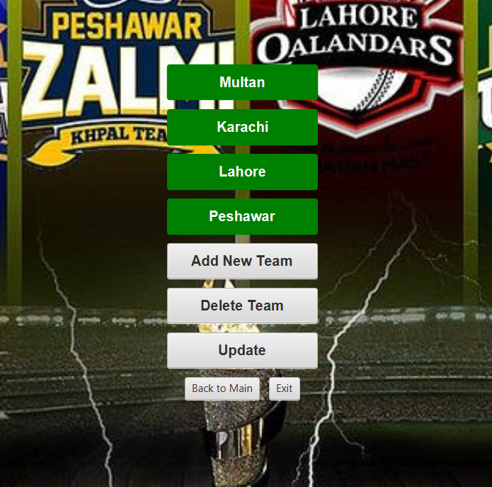

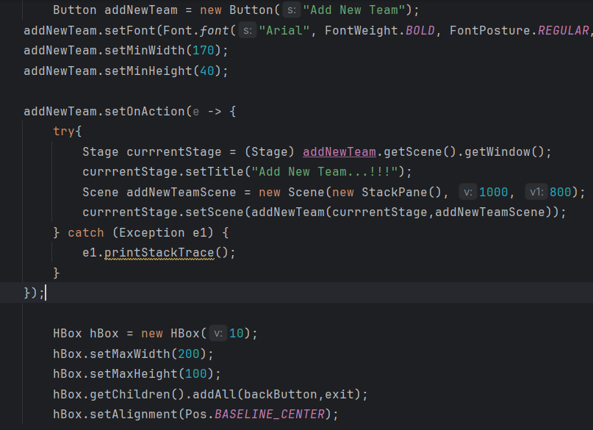

**Teams Page:**

This is the team page. In this page the teams are given in the green buttons.  
when we click on any team button, it shows the details of team.   
there is add new team button. By clicking this button, we can create a new team.  
there is delete team button. By clicking in this button, we can delete a team.

By clicking on back to main button, it takes us back to main screen.

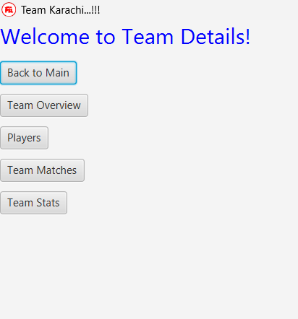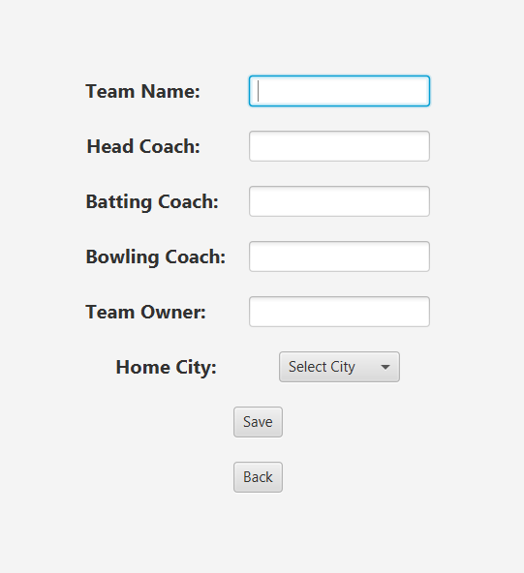

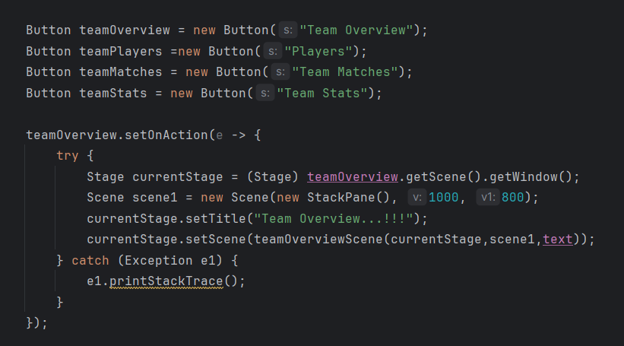

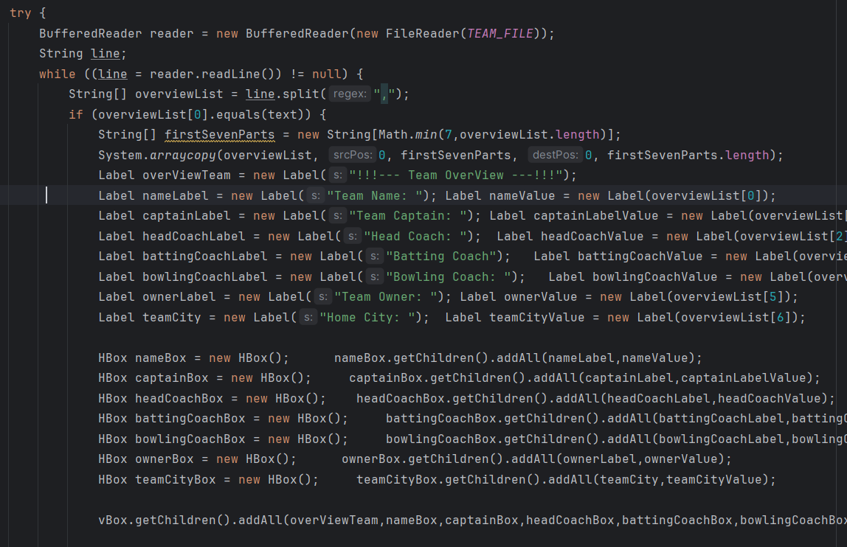

**Team Detail:** the first screen shows the details of team. We can add players in team and we can see the matches of that team and we can also see the stats of that team.

**Add New Team:**

The second page shows the team add form. By this we can add new team. And when we click on save button, it saves the team in the file and creates a button of team.